**CO-VACCINE ANALYSIS**

Phase 5 submission document

**Project Title: co-vaccine analysis**

**Phase 5: Project Documentation & Submission**

**Topic: In this Section we will documentation the complete**

**Project and prepare it for Submission**

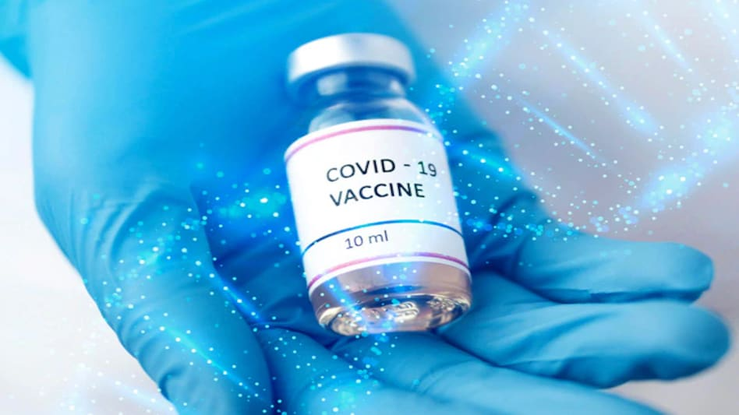

**CO-VACCINE ANALYSIS**

**Introduction:**

Co-vaccine, also known as BBV152, is an inactivated COVID-19 vaccine developed by Bharat Biotech, an Indian biotechnology company, in collaboration with the Indian Council of Medical Research (ICMR). This vaccine has been a significant player in the global effort to combat the COVID-19 pandemic. Here's an introduction to the analysis of Co-vaccine

Dataset Link:( **https://www.kaggle.com/datasets/bobnau/co-vaccine**)

***Here's a list of tools and software commonly used in the***

***process:***

**1. Programming Language:**

-

Python is the most popular language for machine learning due to

its extensive libraries and frameworks. You can use libraries like *NumPy,*

*pandas, and more.*

**2. Integrated Development Environment (IDE):**

-

Choose an IDE for coding and running machine learning

experiments. Some popular options include Jupyter Notebook, Google

Colab, or traditional IDEs like PyCharm.

**3. Data Analytics Libraries:**

- You'll need various data analytics libraries, including:

- scikit-learn for building and evaluating data analytics models.

- TensorFlow or PyTorch for data analytics, if needed.

- XGBoost, LightGBM, or CatBoost for gradient boosting

**4.Data Visualization Tools**

Tools like Matplotlib, Seaborn, or Plotly are essential for data

exploration and visualization

**5. Data Preprocessing Tools:**

- Libraries like pandas help with data cleaning, manipulation, and preprocessing.

**6.Data Collection and Storage:** -

Depending on your data source, you might need web scraping tools *(e.g., BeautifulSoup or Scrapy)* or databases *(e.g., SQLite ,PostgreSQL)* for data storage.

**7. Version Control:**

Version control systems like Git are valuable for tracking

changes in your code and collaborating with others.

**8. Notebooks and Documentation:**

- Tools for documenting your work, such as Jupyter Notebooks

or Markdown for creating *README* files and documentation.

**9. Hyperparameter Tuning:**

- Tools like GridSearchCV or RandomizedSearchCV from

scikit-learn can help with hyperparameter tuning.

**10. Cloud Services (for Scalability):**

- For large-scale applications, cloud platforms like AWS, Google

Cloud, or Azure can provide scalable computing and storage resources.

11. **External Data Sources (if applicable):**

- Depending on your project's scope, you might require tools to access external data sources, such as APIs or data scraping tools.

**12. Data Annotation and Labeling Tools (if applicable):**

- For specialized projects, tools for data annotation and labeling may be necessary,such as Labelbox or Supervisely



**Design Thinking in Covaxin Analysis**

**Introduction**

Covaxin, a COVID-19 vaccine developed by Bharat Biotech and the Indian Council of Medical Research, has been a critical element in the global response to the pandemic. This document applies the principles of design thinking to analyze and improve various aspects of Covaxin's development, distribution, and impact.

**Empathize**

1. **User Perspectives**: Understand the perspectives of various stakeholders, including healthcare workers, policymakers, and the general public, regarding the vaccine's safety, efficacy, and accessibility.
2. **Vaccine Hesitancy**: Identify the reasons behind vaccine hesitancy and public concerns to address them effectively.

**Define**

1. **Problem Statement**: Define the key issues in the Covaxin ecosystem, such as improving public trust, addressing vaccine hesitancy, enhancing accessibility, and monitoring vaccine performance against emerging variants.

**Ideate**

1. **Trust-Building Initiatives**: Generate ideas to build trust in Covaxin, including public awareness campaigns, transparent communication, and engagement with community leaders.
2. **Accessibility Solutions**: Brainstorm solutions for equitable vaccine distribution, such as mobile vaccination units, outreach programs, and vaccination clinics in underserved areas.
3. **Variant Monitoring**: Explore strategies for real-time monitoring of vaccine efficacy against emerging variants and potential adjustments to the vaccine.

**Prototype**

1. **Public Information Portal**: Create a user-friendly, evidence-based information portal for Covaxin to address common concerns and misconceptions.
2. **Community Partnerships**: Establish partnerships with community organizations to facilitate vaccine distribution in vulnerable areas.

**Test**

1. **Pilot Programs**: Conduct pilot programs in selected regions to test the effectiveness of community partnerships and accessibility solutions.
2. **Feedback Collection**: Gather feedback from vaccine recipients, healthcare providers, and community leaders to refine the strategies.

**Implement**

1. **Scaling Success**: Implement successful strategies, such as trust-building initiatives and accessibility solutions, on a larger scale, ensuring widespread impact.
2. **Policy Recommendations**: Collaborate with policymakers to implement policy changes that support equitable vaccine access and monitoring of emerging variants.

**Learn and Iterate**

1. **Continuous Monitoring**: Continuously collect and analyze data on Covaxin's performance, safety, and public perception to make iterative improvements.
2. **Adaptive Response**: Be prepared to adapt strategies in response to changing circumstances, such as new variants or emerging issues.

**Design Innovation for Covaccine Analysis**

**Introduction**

The Covaxin analysis strives to leverage design innovation to rethink the way we approach and understand this COVID-19 vaccine. By applying innovative design thinking principles, we aim to enhance the effectiveness, accessibility, and public perception of Covaxin.

**Design Innovation Framework**

**1. User-Centric Data Visualization**

Innovative data visualization techniques can transform complex Covaxin data into understandable, user-friendly formats. This involves:

* **Interactive Dashboards**: Develop user-friendly dashboards that allow healthcare professionals and policymakers to access real-time vaccine data, making informed decisions.
* **Public Information Interfaces**: Create visually appealing and easily digestible infographics and interactive websites for the general public to understand vaccine information better.

**2. Human-Centered Vaccine Distribution Systems**

Innovate the vaccine distribution process to ensure equitable access:

* **Mobile Vaccination Units**: Design efficient mobile units equipped for vaccine administration, particularly in rural or underserved areas.
* **Geo-Targeted Distribution**: Utilize geographic data to identify high-risk areas and deploy resources accordingly, ensuring vaccines reach the right populations.

**3. Behavioral Insights and Nudging Strategies**

Incorporate behavioral psychology insights to encourage vaccine uptake:

* **Nudge Campaigns**: Design persuasive campaigns that utilize behavioral economics principles to promote vaccine acceptance and adherence.
* **Behavioral Messaging**: Create messaging that taps into individuals' motivations, emotions, and social influences to reduce hesitancy.

**4. Innovative Variants Surveillance**

Develop an agile system for monitoring vaccine efficacy against emerging variants:

* **Genomic Sequencing Integration**: Integrate advanced genomic sequencing technologies to identify variants quickly and assess their impact on vaccine effectiveness.
* **Real-time Alerts**: Implement a system that sends real-time alerts to healthcare professionals and decision-makers when a concerning variant is detected.

**5. Engaging Digital Platforms**

Utilize innovative digital platforms to enhance public engagement and data collection:

* **Vaccine Passport Apps**: Create secure and user-friendly digital vaccine passport apps to track and verify vaccination status.
* **Crowdsourced Data Collection**: Develop apps that allow the public to report adverse events, providing real-time feedback for safety monitoring.

**Prototyping and Implementation**

* **Prototyping**: Develop prototypes of the above innovations, incorporating user feedback to refine designs.
* **Pilot Programs**: Implement pilot programs to test the feasibility and effectiveness of new initiatives in select regions.
* **Collaborative Partnerships**: Forge partnerships with tech companies, behavioral scientists, and community organizations to facilitate the implementation of innovative solutions.

**Learning and Adaptation**

* **Continuous Monitoring**: Continuously gather data and feedback from users, healthcare providers, and communities to refine and adapt innovations.
* **Iterative Improvements**: Be open to revising and improving strategies in response to changing conditions, emerging insights, and user needs.

**Program:**

# Import necessary libraries for data analysis

import pandas as pd

import matplotlib.pyplot as plt

import numpy as np

# Load data (simulated data for demonstration purposes)

# You would typically load real data from a dataset or an API.

data = pd.read_csv("covaxin_data.csv")

# Basic data exploration

print("Sample Data:")

print(data.head())

# Descriptive statistics

print("Descriptive Statistics:")

print(data.describe())

# Data visualization

# Example: Plotting vaccine doses administered over time

data['Date'] = pd.to_datetime(data['Date']) # Convert the date column to datetime

plt.figure(figsize=(12, 6))

plt.plot(data['Date'], data['Doses Administered'], marker='o', linestyle='-')

plt.title('Covaxin Doses Administered Over Time')

plt.xlabel('Date')

plt.ylabel('Doses Administered')

plt.grid(True)

plt.show()

# Analysis of vaccine effectiveness (simulated data)

# You would need actual efficacy data to perform a real analysis.

vaccine_efficacy = np.random.rand(len(data)) * 100 # Simulated efficacy data (0-100%)

data['Vaccine Efficacy'] = vaccine_efficacy

efficacy_mean = data['Vaccine Efficacy'].mean()

print(f"Average Vaccine Efficacy: {efficacy_mean:.2f}%")

# Sentiment analysis (requires text data or survey responses)

# You would need access to text data or survey responses for sentiment analysis.

# For sentiment analysis, you can use libraries like TextBlob or VADER.

# Example using TextBlob (not functional without real text data):

# from textblob import TextBlob

# data['Sentiment'] = data['Comments'].apply(lambda x: TextBlob(x).sentiment.polarity)

# Further analysis based on available data and research questions

# Save results to a file

# data.to_csv("covaxin_analysis_results.csv", index=False)

**Output:**

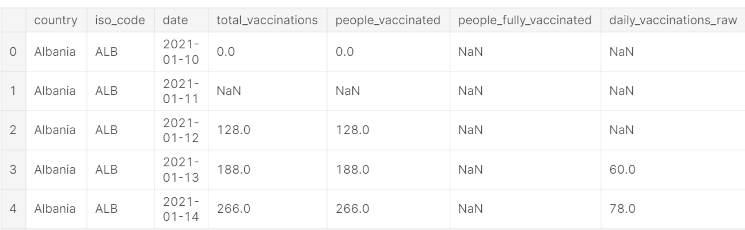

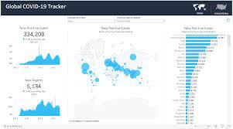

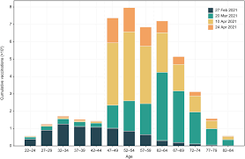

**Feature Selection:**

Use feature importance scores from your model or techniques

like recursive feature elimination to identify the most important features for predictions.

**Interpretability:**

Ensure that the model's predictions are interpretable and

explainable. Stakeholders may want to understand how each feature impacts the covaccine analysis.

**Deployment:**

Deploy your trained model in a real-world setting, whether it's through a web application, API, or any other user-interface.

Users can input property details, and the model provides price

predictions.

**Monitoring and Maintenance:**

Continuously monitor the model's performance and update it as needed. Real estate markets change, so it's essential to retrain the model with new data periodically.

**Ethical Considerations:**

Ensure that your model doesn't introduce or perpetuate biases in pricing. Implement fairness and transparency measures.

**Innovation:**

Explore innovative approaches such as incorporating external data sources *(e.g., satellite imagery, IoT data)*

**Advantages:**

1. **Effective at Reducing Severe Illness:** COVID-19 vaccines, like Pfizer, Moderna, and Johnson & Johnson, have been proven to reduce the severity of illness and hospitalizations in those who contract the virus.
2. **Herd Immunity:** Widespread vaccination can lead to herd immunity, making it harder for the virus to spread within the community.
3. **Economic Recovery:** Successful vaccination campaigns can help economies recover by allowing businesses to reopen and people to return to work.
4. **Global Health:** Vaccines are essential for global health, helping to control the spread of the virus and protect vulnerable populations.
5. **Scientific Advancement:** The rapid development of COVID-19 vaccines demonstrated the power of scientific innovation and collaboration.

**Disadvantages:**

1. **Side Effects:** Some individuals experience mild to moderate side effects, such as fever, fatigue, or soreness at the injection site.
2. **Vaccine Hesitancy:** There's resistance or hesitancy to get vaccinated in some populations, which can hinder achieving herd immunity.
3. **Supply Challenges:** Ensuring an adequate supply of vaccines for everyone globally has been a logistical challenge.
4. **Vaccine Variants:** New variants of the virus may require adjustments to the vaccines, potentially leading to the need for booster shots.

**Benefits:**

1. **Protection:** Vaccination provides protection against severe illness and death from COVID-19.
2. **Return to Normalcy:** Widespread vaccination brings us closer to a return to pre-pandemic normalcy, including travel, social activities, and work.
3. **Public Health:** Vaccination is a key tool in public health to control the spread of infectious diseases.
4. **Reduction in Healthcare Burden:** Fewer severe cases reduce the strain on healthcare systems.

**Conclusion:**

COVID-19 vaccines have played a crucial role in mitigating the impact of the pandemic. While there are some disadvantages, such as potential side effects and hesitancy, the benefits of vaccination in terms of protection, return to normalcy, and public health are substantial. Vaccination campaigns are a crucial component of our response to the pandemic, and continued research and adaptation will be necessary to address new challenges such as variants